Hello!

My name is Kristine Kalaw and I am working on my thesis entitled "***Recognizing Reader’s Affect Using EEG Data***" for my master’s degree in Computer Science. To give a brief background, my research is about associating brainwaves to specific emotions while a person is reading fiction. In line with this, I am looking for volunteers for my data collection. You will be asked to read a short story and then annotate/tag your emotions, while wearing an [Emotiv Insight EEG headset](https://www.emotiv.com/insight/" \t "_blank) (see Fig1).

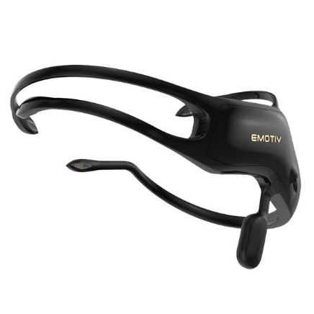

*(Fig 1)*

Data collection schedules will be from **January 11 to February 3** at **Gokongwei Bldg. 409 (Center for Language Technologies Lab)** from 9:15am to 5:45pm every Monday to Friday. Set an appointment using this link <https://tinyurl.com/ReaderAffectModel-Schedule>. Log-in to your Google or DLSU account, choose your preferred schedule (see Fig2), and then **input your contact number and email in the Description box** (see Fig3). Note that should you choose to participate, it could take up at least an hour of your time. Rest assured that you will be compensated (not in cash!) for your participation.

For more information about the data collection, see this link <https://tinyurl.com/ReaderAffectModel-ConsentForm>. You may also send me an email at [kristine\_ma\_kalaw@dlsu.edu.ph](mailto:kristine_ma_kalaw@dlsu.edu.ph).

Thank you!

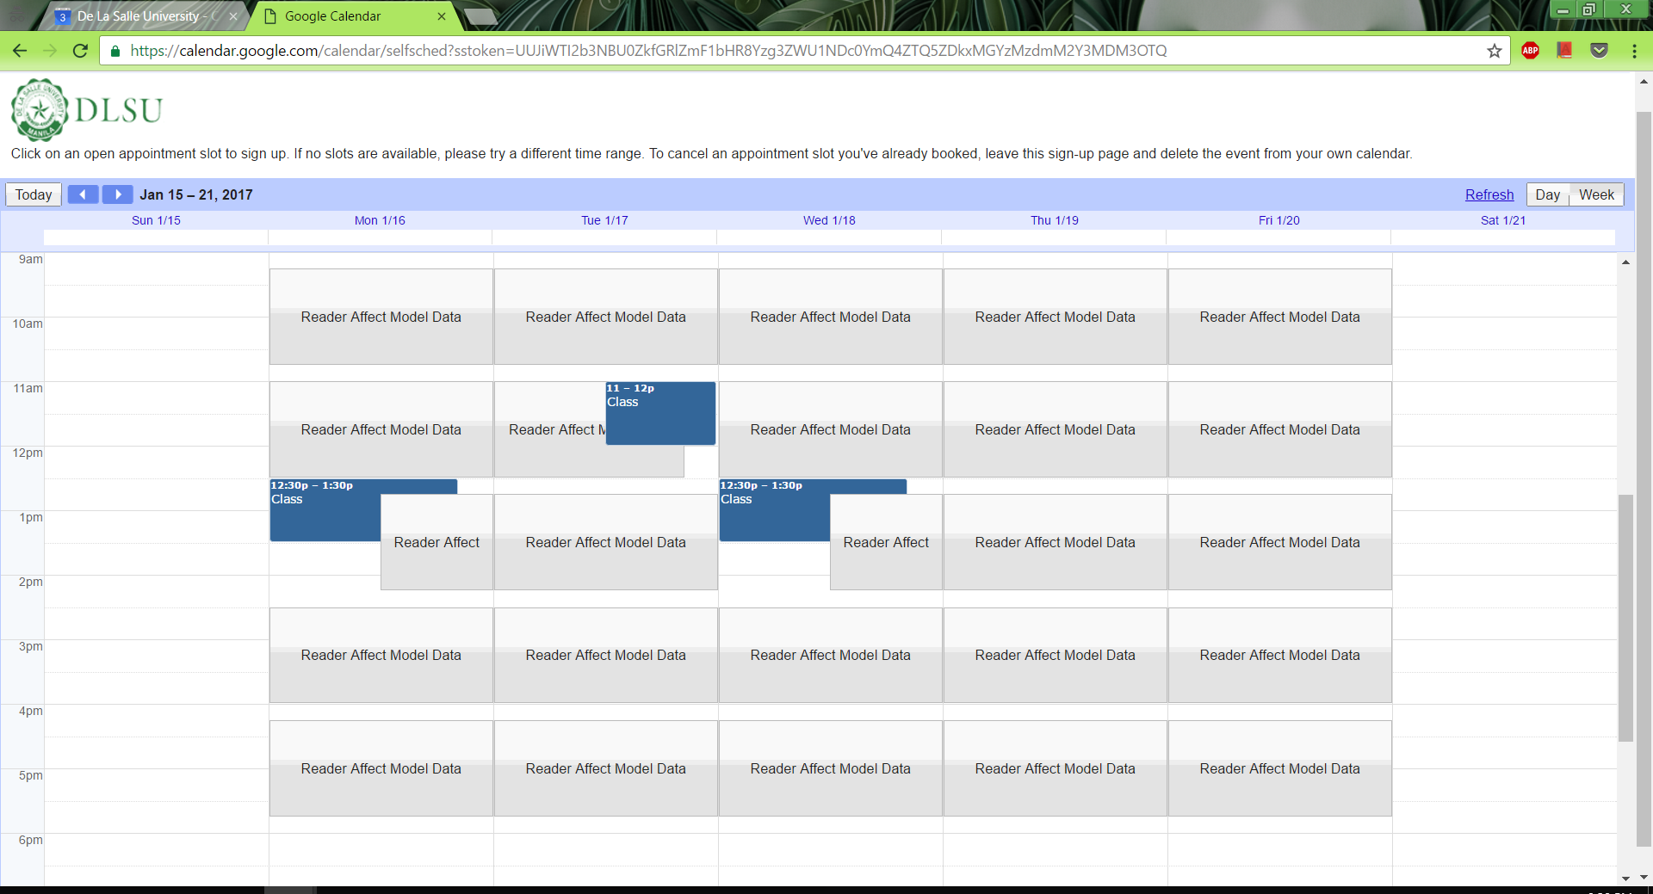

*(Fig 2)*

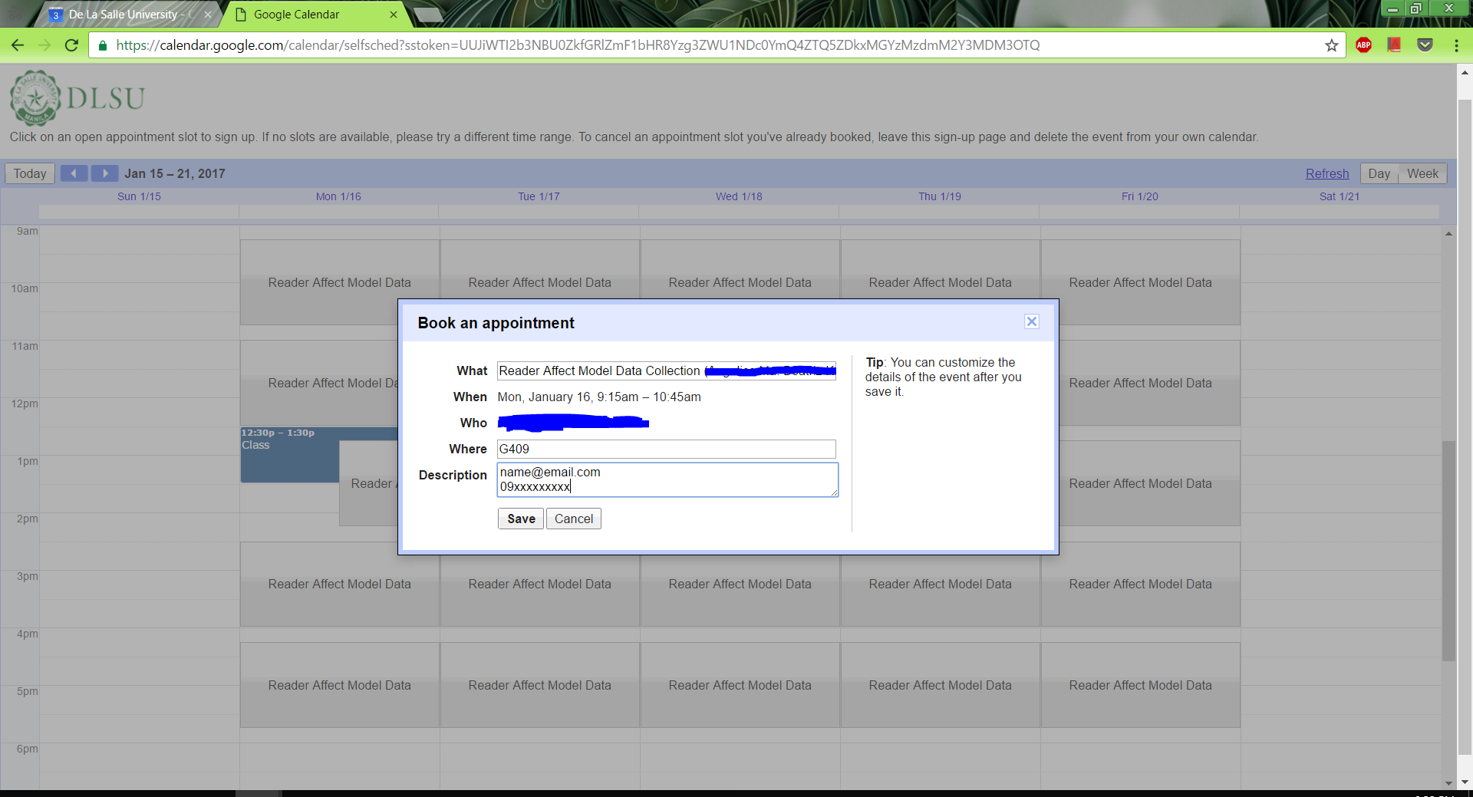

*(Fig 3)*